Zephyrus

Drum & Bugle Corps

Medical Guide & Emergency Plans

2023
Table of Contents
- Introduction
- Reduced level of consciousness
- Respiratory Distress
- Rescue Breathing
- Treating Airway Obstruction in a conscious Victim
- Anaphylaxis (Closed airway due to allergic reaction)
- Chest Pain
- Cardiopulmonary Resuscitation Sequence of CPR (Adult and Child) and
Automated External Defibrillator (AED)
- Heat exhaustion and Heat stroke
- Vomiting, diarrhea and nausea.
- Diabetic emergencies (Low blood sugar)
- Concussion
- Stroke
- Seizures
- Sudden Illness
- Bleeding precautions
- Poisoning editing
- Musculoskeletal injuries
- Sprain Injuries
- General Wounds
- Eye Injury
- Mouth and teeth injuries
- Impaled Object
- Burns
- Bites & Stings
- Shock
- Natural disaster
- Thunderstorm/Tornado Precautions

1.Be Smart, Get Prepared!
This guide was constructed to advise and educate staff members on general information on first aid recommendations and safety precautions during Zephyrus Drum Corps activities. First aid is emergency treatment given before professional medical care is available. Deciding what, when and how action should be taken is important for responding to an emergency which can arise at any time during activities outdoor and indoor. The information contained in this guide was constructed to incorporate the most accurate information available at the time of being written and will need to be rechecked yearly to ensure written material and methods are up to date to best practices and medical guidelines.
Also, of note this guide is brief and focuses on initial treatment options and broad safety recommendations. For complete treatment and further instructions contact professional medical help immediately via 911 or other emergency services available in your immediate area to assist in your emergency.
If there are certain topics seen missing from this guide or recommendations that you may see as beneficial, please contact a lead member of the staff so we may make proper additions.
Thank you!

2.Reduced Level of Consciousness
Person/persons found to be in a reduced level of alertness and /or not responding appropriately to their norm.
- Survey the Scene.
- Is the scene safe?
Use smart judgment if you can assist a person without encountering harm and becoming injured yourself. Example. Is the person laying out on a busy traffic intersection after collapsing or are they laying out alone on the grass in the football field? This will determine your initial approach.
- What happened?
Try to determine what happened? Did you see this person get injured? Suddenly collapse? Or did you just happen to find them? Is there someone with them that can give you more information on what happened?
- How many victims of injury are there?
Try to assess the area if there is more than one person involved in this incident. This will help assist in allocating appropriate response personnel and resources if there are many injured.
- Can witnesses or others present at the site of the incident help?
If 911 emergency response personnel are called/needed it may take some time for them to arrive at the scene. If other able body persons are present, ask and plan together how best they can assist. Example. You and another person find someone collapsed on the ground with a reduced level of consciousness. One person can stay with the victim while the other person can call for help 911 and find other members of staff to help with the incident.
- Do a primary survey and care for life-threatening problems.
- Check for level of consciousness. Can they speak and/or respond to touch? Can they tell you, their name? birthday? What year it is? What happened to them?
- If unconscious immediately call 911
- Roll person on back (if necessary to check ABCs)
- Check ABCs (Airway, Breathing, Circulation)
- Open Airway-Tilt head back and lift chin
- Check for Breathing-Look, listen and feel for breathing for about 5 seconds. Keep the airway open and monitor breathing.
- If person is not breathing: Keep head tilted back. Pitch nose shot. Seal your lips tightly around the person’s mouth. Give 2 slow breaths, each lasting about 1 to 1.5 seconds. Watch chest rise to see that your breath goes in.
- Check for circulation of blood-by checking pulse & signs of external bleeding. * See bleeding/wound section
- Check for Pulse-Locate Adams apple. Slide your fingers down into the groove of the neck on the side that is closest to you. Feel for pulse for about 5-10 seconds.
- If no pulse start CPR! *See CPR section
- Do a secondary survey if the person is conscious.
- Further question the person to determine what happened to them and their present symptoms.
- Check vital signs to the extent of the appropriate available monitoring equipment you have readily available and training to use them (Thermometer, blood pressure cuff, stethoscope, pulse oximeter).
Check and record temperature, breathing rate, pulse rate, blood pressure and oxygenation levels to give to responding medical personnel.
Normal vitals *Can vary based on age, sex weight and overall health*
Temp: 98.2 F Blood pressure: 120/80 Heart rate: 60-99 beats per min Respirations: 12-20 Sp02: >93%
- Perform Head to toe examination A more thorough assessment checking other possible areas of injury such as ears, eyes, nose throat, neck, shoulders, chest, abdomen, arms, hips and legs.
3.Respiratory Distress
Describes symptoms related to breathing problems. There can be many causes of respiratory distress. General causes can be due to infections, chronic illness (asthma, allergies), direct injury to the head or abdomen or possibly a blocked airway from improper food ingestion or anaphylaxis (allergic reaction causing blocked airway).
General Symptoms: Victims cannot catch their breath. They may appear to breathe faster or slower than normal. May have deep or shallow breaths. They may make wheezing/gurgling sounds. May describe feeling anxious or vocalize that they cannot catch their breath. Skin may be moist and appear flushed, pale or bluish. Victim may also experience dizziness and chest pain or tingling in hands and feet.
Treatment:
- If the victim is breathing, help them rest in a comfortable position and area.
- Question the victim if they are able to tell you what may be causing their difficulty breathing.
- Provide enough air by moving them away or limiting them from simulants that could be causing them respiratory distress such as…Excessive physical activity, excessive heat or cold exposure, exposure to pollen from outdoors, strong smells from possible smoke, strong cleaning chemicals, perfumes/deodorants/canned sprays or foods with a strong smell.
- Once removed from possible stimulants
- Provide reassurance to the victim if conscious and provide treatment based on environmental factors and information given to you from the victim.
- If a victim’s beathing returns to normal after initial treatment continue to monitor and weigh benefits if they would need to see and be evaluated by professional medical care and if victim would be willing to consent to that if over the age of 18. If under aged parent will be notified for input of transition of care.
- If victims breathing doesn’t return to normal and continues to rapidly worsen call 911
- If they lose consciousness… *see loss of consciousness, rescues breathing and CPR sections for instructions next actions.

4.Rescue Breathing
Rescue breathing is a lifesaving technique that involves exhaling into the airway and lungs of a person who has stopped breathing.
- Maintain open airway. With head tilt/chin-lift. Pinch nose shut.
- Give 1 slow breath every 5 seconds.
- Watch chest to see that your breaths go in. Continue for 1 min-about 12 breaths.
- Recheck pulse and beathing every minute. Feel pulse for about 5-10 seconds.
- If person has a pulse and is breathing. Keep the airway open.
- Monitor breathing and await arrival of 911 emergency personnel.
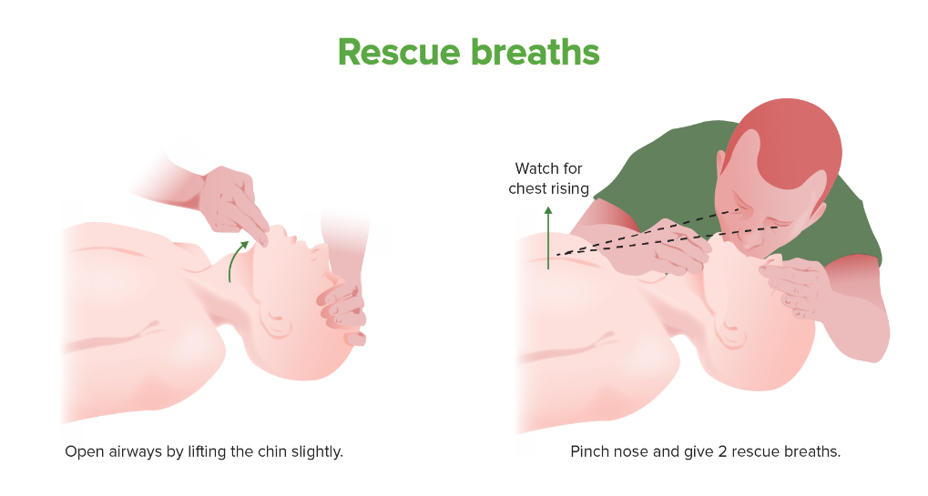

5.Treating Airway Obstruction (Choking)
in a conscious individual
- Determine if person is choking.
- The universal distress signal for choking is grabbing the throat with one or both hands.
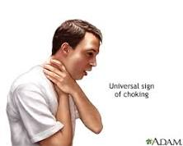
If a choking person can cough forcefully, let the person keep coughing.
Coughing might naturally remove the stuck object.
If a person can't cough, talk, cry or laugh forcefully, give first aid to the person.
The American Red Cross recommends the following steps:
- Give five back blows. Stand to the side and just behind a choking adult. For a child, kneel down behind. Place your arm across the person's chest to support the person's body. Bend the person over at the waist to face the ground. Strike five separate times between the person's shoulder blades with the heel of your hand.
- Give five abdominal thrusts. If back blows don't remove the stuck object, give five abdominal thrusts, also known as the Heimlich maneuver.
- Alternate between five blows and five thrusts until the blockage is dislodged.
Some sources only teach the abdominal thrust. It's OK not to use back blows if you haven't learned the back-blow technique. Both approaches are acceptable for adults and children older than age 1.

To give abdominal thrusts to someone else:
- Stand behind the person. For a child, kneel down behind. Place one foot slightly in front of the other for balance. Wrap your arms around the waist. Tip the person forward slightly.
- Make a fist with one hand. Put it just above the person's navel.
- Grasp the fist with the other hand. Press into the stomach, also called the abdomen, with a quick, upward thrust — as if trying to lift the person up. For a child, use gentle yet firm pressure to avoid damaging the internal organs.
- Give five abdominal thrusts. Check if the blockage has been removed. Repeat as needed.
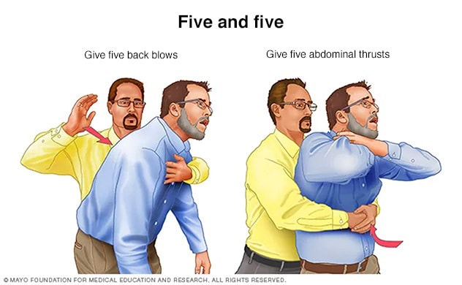
If you're the only rescuer, give back blows and abdominal thrusts first. Then call 911 for help. If another person is there, have that person call for help while you give first aid.
- If the person becomes unconscious *See loss of consciousness, rescue breath and CPR sections. Will need to start standard cardiopulmonary resuscitation (CPR) with chest compressions and rescue breaths.
https://www.mayoclinic.org/first-aid/first-aid-choking/basics/art-20056637

If the person is pregnant or if you can't get your arms around the stomach, give chest thrusts:
- Put your hands at the base of the breastbone, just above the joining of the lowest ribs.
- Press hard into the chest with a quick thrust. This is the same action as the Heimlich maneuver.
- Repeat until the blockage is removed from the airway.
To clear the airway of an unconscious person:
- Lower the person onto the floor, with the back on the floor and arms to the sides.
- Clear the airway. If you can see the object, reach a finger into the mouth to sweep out the object. Never finger sweep if you can't see the object. You risk pushing the blockage deeper into the airway. This is very risky with young children.
- Call 911 and Begin CPR if the person still doesn't respond and does not have a pulse. *See CPR section.
If the airway is still blocked, use chest compressions such as those that are used in CPR to remove the stuck object. Only use two rescue breaths per cycle. Recheck the mouth regularly for the object.

6. Anaphylaxis
Serious, life-threatening allergic reaction. The most common anaphylactic reactions are to foods, insect stings, medications, and latex. A persons immune system overreacts to specific a allergen by releasing chemicals that cause allergy symptoms leading to the air way to close.
Symptoms: vary based on degree of allergy and the amount of exposure. mild to severe. Possible symptoms include:
- swelling in mouth, throat, or other body part
- hives, rash, or itchy skin
- pale skin, or skin that is red and warm (flushed)
- trouble breathing or gasping for breath
- a tight feeling in your chest
- dizziness and or fainting
- stomach pain
- nausea, vomiting, or diarrhea
- feeling of anxiety
- low blood pressure
- cardiac arrest!!!!!

Call 911 immediately if you suspect someone is having anaphylaxis :
- Identify if he or she is carrying an epinephrine autoinjector EPI Pen to treat allergic reaction.
- Have the person sit in a chair or lie still on his or her back per initial symptoms.
- Loosen tight clothing and cover the person with a blanket
- Do not give them anything to drink
- If there’s vomiting or bleeding from the mouth, turn the person on his or her side to prevent choking.
- If there are no signs breathing, coughing or movement begin CPR (if you have a CPR certified staff member) if not being hands only CPR.
- Victim will require emergency treatment even if symptoms start to improve.
Allergens that may cause anaphylaxis include:
- foods, such as shellfish, nuts, peanuts, eggs, and fruits
- medicines, such as antibiotics, aspirin, over-the-counter pain relievers, allergy shots, and contrast dye for imaging procedures
- latex or rubber found in surgical gloves, medical supplies, and many products in your home
- insect stings, such as from bees, wasps, hornets, yellow jackets, sawflies, and fire ants
*Remove source of allergen away from person as soon as possible if able too.
7.Chest pain
Chest pain is discomfort or pain that one may feel anywhere along the front of one’s body between the neck and upper abdomen that may also radiate to the shoulders and upper back. Chest pain can have causes that aren't due to an underlying disease such as irregular heartbeats (Arrhythmias) or heart blockage (coronary heart disease). Some examples of causes include heavy lifting, weight lifting, trauma to the chest, or swallowing a large piece of food or generalized stomach upset causing reflux of food. Serious causes of chest pain however can lead to heart attack/cardiac arrest so any initial complaint of chest pain should be investigated and viewed with immediate caution.
A heart attack is when one of the coronary arteries becomes blocked. The heart muscle is robbed of its vital blood supply and, if left untreated, will begin to die because it is not getting enough oxygen. Process is slower than cardiac arrest.
A cardiac arrest is when a person's heart stops pumping blood around their body, and they stop breathing normally. Process is much faster than a heart attack and can occur within minutes depending on the cause.
Heart attack signals:
- Victim has persistent complaints of chest pain or discomfort and breathing difficulty.
- Pulse is present. Changes in pulse rate/heartbeat. Complaints of irregular heartbeats.
- Changes in skin appearance. Pale and sweaty
- Complaints of Nausea and cold sweats.
Cardiac arrest signals:
- Victim is unconscious, non-responsive, not breathing and has no pulse.
- Cardiac arrest can result from a heart attack, but it can also occur suddenly, independent of a heart attack.
Treatment
- Investigate causes of chest pain and remove victim from stimulants or previously mentioned activities/causes that may be source of chest pain.
- Be aware of heart attack/cardiac arrest signals.
- Comfort the victim and provide reassurance that we will get help.
- Call 911 or have fellow staff/bystander call for help. Make sure they come back to confirm help is on the way or have a way to confirm with you that 911 has been called via telephone.
- Assess the level of consciousness and take 5-10 seconds to check pulse.
- If victim has loss of consciousness with no response and no pulse proceed with CPR as described in next section.

8.Cardio Pulmonary Resuscitation (CPR)
CPR is an emergency lifesaving procedure performed when the heart stops beating. Immediate CPR can double or triple the chances of survival after cardiac arrest.
Why Is CPR Important?
Keeping the blood flow active – even partially – extends the opportunity for a successful resuscitation once trained medical staff arrive on site.
Chain of Survival
CPR is a critical step in the American Heart Association (AHA) Chain of Survival.
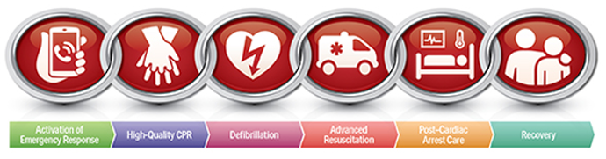

The 6 links in the adult out-of-hospital Chain of Survival are:
- Recognition of cardiac arrest and activation of the emergency response system (911)
- Early CPR with an emphasis on chest compressions
- Rapid defibrillation
- Advanced resuscitation by Emergency Medical Services and other healthcare providers
- Post-cardiac arrest care
- Recovery (including additional treatment, observation, rehabilitation, and psychological support)
A strong Chain of Survival can improve chances of survival and recovery for victims of cardiac arrest.
There are two commonly known versions of CPR:
- For healthcare providers and those trained: conventional CPR using chest compressions and mouth-to-mouth breathing at a ratio of 30:2 compressions-to-breaths. In adult victims of cardiac arrest, it is reasonable for rescuers to perform chest compressions at a rate of 100 to 120/min and to a depth of at least 2 inches (5 cm) for an average adult, while avoiding excessive chest compression depths (greater than 2.4 inches [6 cm]).
- For the general public or bystanders who witness an adult suddenly collapse: compression-only CPR, or Hands-Only CPR. Hands-Only CPR is CPR without mouth-to-mouth breaths. It is recommended for use by people who see a teen or adult suddenly collapse in an out-of-hospital setting (such as at home, at work, or in a park).
- For those professionally trained in CPR and have achieved Basic Life Support (BLS) certification by an authorized heath associated such as the American Heart Association (AHA). Proceed with CPR as you have been trained to do so. For public and staff not certified perform Hands-Only CPR as according to the information and videos available in these resources from AHA in the link provided below.
HANDS ONLY CPR American Heart Association Review!!!!
https://www.youtube.com/watch?v=M4ACYp75mjU
https://cpr.heart.org/en/cpr-courses-and-kits/hands-only-cpr
(Automated External Defibrillator) AED Usage
https://newsroom.heart.org/multimedia/animation-video/cpr-and-aeds-9749/aeds
https://www.youtube.com/watch?v=jR7V3_l-aLw
9.Heat Exhaustion and Heat stroke
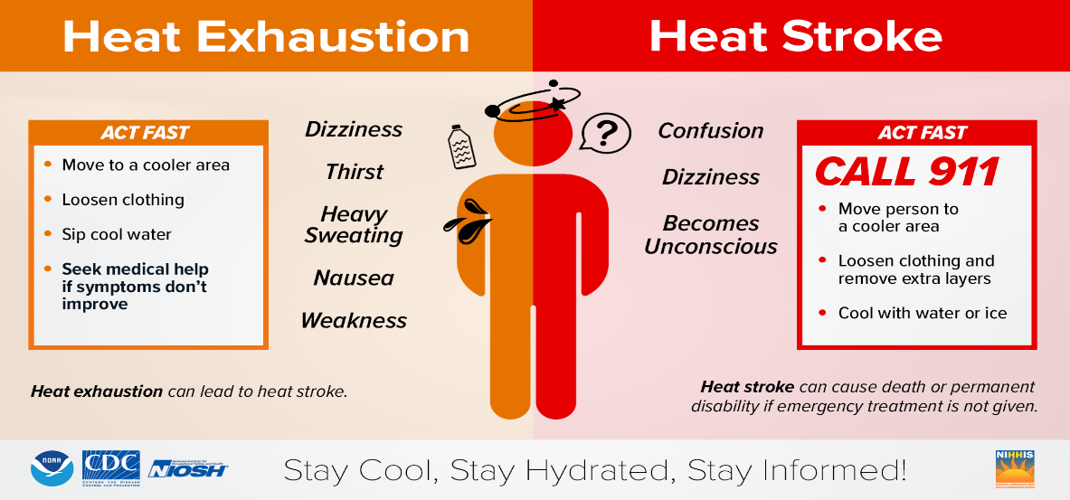
If you suspect that someone has a heat stroke, immediately call 911.

Symptoms:
- Core body temperature above 104 degrees Fahrenheit
- Fainting
- Throbbing headache
- Dizziness and light-headedness
- Lack of sweat despite the heat
- Red, hot, and dry skin
- Muscle weakness or cramps
- Nausea and vomiting
- Rapid heartbeat, may be strong or weak
- Rapid, shallow breathing
- Confusion, disorientation, or staggering
- Seizures (irregular uncontrolled movements)

Treatment:
If possible, take the person’s core body temperature and initiate first aid to cool it to 101 to 102 degrees Fahrenheit.
Utilize Cooling strategies:
- Place in a tub of cool water or a cool shower.
- Spray with a spray bottle or garden hose if available .
- Sponge with cool water.
- Fan while misting with cool water.
- Place ice packs or cool wet towels on the neck, armpits and groin.
- Cover with cool damp sheets.
- Don't give sugary, caffeinated or alcoholic beverages to a person with heatstroke. Also avoid very cold drinks, as these can cause stomach cramps.
- Begin CPR if the person loses consciousness and shows no signs of circulation, such as breathing, coughing or movement.
Preventing Heat exhaustion and Heat Stroke:
When the heat index is high, it’s best to stay in an air-conditioned environment. If you must go outdoors, you can prevent heat exhaustion and heat stroke by taking these steps:
- Wear lightweight, light-colored, loose-fitting clothing. Encourage long sleeves. Hats.
- Use a sunscreen with a SPF of 30 or more
- Drink extra fluids. Heat related illness can result form salt depletion so it may be advisable to substitute an electrolyte-rich sports drink
- General recommendation is to drink 24-32 ounces of fluid two hours before exercise. During exercise, you should consume another 8 ounces of water every 20 minutes
Dehydration
Seek medical attention immediately if victim:
- Hasn’t peed in 8 hours
- Has had a seizure
- Is disoriented or confused
- Has a weak or rapid pulse
- Feels very tired
- Feels dizzy when they stand
- Are too sick to take in fluids
Mild or Moderate symptoms:
- Thirst
- Dry or sticky mouth
- Not peeing very much
- Dark yellow pee
- Headache
- Muscle cramps
Initial Treatment
- Drink some fluids before the activity begins
- Drink at regular intervals (every 20 mins or so) during the course of the activity and after it ends.
Vomiting, Diarrhea and Nausea
Call 911 and get medical care if the person has any of the following symptoms:
- Pain in the middle of lower right side of the abdomen
- Severe Headache or stiff neck and eyes unable to view light directly
- Vomiting blood or blood in stool
- Confusion or lethargy
- Chest pains
- High fever over 101 F
- Can’t keep down liquids or foods for more than 24 hours
- Fever with abdominal pain
- Signs of moderate dehydration
- Vomiting and diarrhea both present at the same time
Treatment for Nausea and vomiting:
- Have the person drink small amounts of water, sports drinks, or clear liquids
- If the person can keep it down, give the person light, bland foods like crackers
- Have the person drink small amounts of water, sports drinks, or clear liquids.
- Avoid fried greasy foods as well as Juices as these can upset the stomach more
- Don’t give the person solid foods until vomiting has stopped
- When the person can tolerate food, try small amounts of foods like bananas, rice, applesauce, and toast
- Monitor for dehydration dry lips, mouth and sunken eyes, rapid breath or pulse.

Sprain/Strain joint injury
Seek hospital care if:
- If joint is misshapen or area extremely swollen
- Cannot move joint and or extremity without severe pain
- Severe pain during minimal touch
Seek medical care if:
- Pain is severe or uncontrolled despite over the counter medications, elevation, and Ice
- You cannot move joint and or extremity without severe pain.
- Your ankle fails to improve within 5-7 days
Symptoms:
Sprains
- Pain.
- Swelling.
- Bruising.
- Difficulty moving the joint.
Strains
- Muscle spasms
- Pain
- Swelling.
- Cramping.
- Trouble moving injured area

Treatment:
- Rest – to prevent further injury and avoid stress on inflamed tissue
- Ice – counteract the increased blood flow, reduce swelling, redness and warmth
- Compression wrap bandage to keep down swelling
- Elevation of area to help reduce swelling
- Anti-inflammatory pain medications such as Ibuprofen
Fracture (Broken Bone)
In the case of a fracture call 911 immediately.
Take caution…
- If the person is unresponsive, isn’t breathing or isn’t moving
- If there is heavy bleeding
- If even gentle pressure or movement causes pain
- If the limb or joint appears deformed
- If the bone has pierced the skin
- If the extremity of the injury is numb or bluish at the tip
- If you suspect a bone is broken in the neck, head, or back
Treatment:
Do not move the person except if necessary to avoid further injury.
- Stop any bleeding: apply pressure to the wound with a sterile bandage, a clean cloth or a clean piece of clothing
- Immobilize the injured area: do not try to realign the bone or push a bone that’s sticking out back in
- Apply ice packs to limit swelling and help relieve pain
- Treat for shock: if the person feels faint or is breathing in short, rapid breaths, lay the person down with the head slightly lower than the drunk, if possible, elevate the legs

Seizure
What is a seizure? A seizure is a burst of uncontrolled electrical activity between brain cells (also called neurons or nerve cells) that causes temporary abnormalities in muscle tone or movements (stiffness, twitching or limpness), behaviors, sensations or states of awareness.
Call an ambulance immediately if:
- It is the person’s first seizure
- They have injured themselves badly
- They have trouble breathing after the seizure has stopped
- One seizure immediately follows another with no recovery in between
- The seizure lasts two minutes longer than what is usual for them
- The seizure lasts for more than five minutes
Treatment:
- Stay calm
- Look around – is the person in dangerous place? If not, don’t move them.
- Note the time the seizure starts
- Stay with them – if they don’t collapse but seem blank or confused, gently guide them away from any danger
- Cushion their head if they collapsed
- Don’t hold them down
- Don’t put anything in their mouth
- Check the time again – call ambulance if the seizure lasts longer than 5 minutes
- After seizure has stopped put them into the recovery position and check that their breathing is returned to normal. Check mouth to see that nothing is blocking their airway. If breathing sounds difficult after the seizure has stopped, call ambulance
- Stay with them until they are fully recovered

Power Outage
- Make sure a phone and or laptop is always charged. This way, you may access offline features of your organizational software or files on your desktop.

- Make sure you have access to critical information that is not reliant on an internet connection to retrieve.
Natural Disasters
Fire:
- Immediately pull the nearest fire alarm pull station as you exit the building.
- When evacuating the building, be sure to feel doors for heat before opening them to be sure there is no fire danger on the other side.
- If there is smoke in the air, stay low to the ground, especially your head, to reduce inhalation exposure. Keep on hand on the wall to prevent disorientation and crawl to the nearest exit.
- Once away and clear from danger, call your report contact and inform them of the fire.
- Go to your refuge area and await further instructions from emergency personnel.
- Contact parents
Tornado:
If you are in a gymnasium or auditorium:
- Large buildings with wide-span roofs may collapse if a tornado hits.
- If possible, find shelter in another building.
- If you are in one of these buildings and cannot leave, take cover under a sturdy structure such as a table or desk.
In all cases:
- Get as close to the ground as possible, protect your head and watch for flying debris.
- Do not chase tornadoes - they are unpredictable and can change course abruptly.
- A tornado is deceptive. It may appear to be standing still but is, in fact, moving toward you.
Flooding:
Flash floods develop quickly
- Do not wait until you see rising water
- Get out of low areas and move to high ground
- Do not drive through flooded areas
- Keep clear of power lines and electrical wires
- Avoid flooded areas and do not attempt to cross flowing water

Lightning:
Lightning is one of the most deadly natural disasters.
- At least one on-site staff member must have notifications on for a lightning tracking app at all times.
- If lightning strikes within 10 miles, all activities must move inside until at least 15 minutes after the last strike within 10 miles.

References
Anaphylaxis | Anaphylactic Shock. (2019, January 30). Retrieved July 10, 2019, from https://medlineplus.gov/anaphylaxis.html
Dehydration. (2019, May 29). Retrieved July 10, 2019, from https://medlineplus.gov/dehydration.html
Fractures (broken bones): First aid. (2018, February 10). Retrieved July 10, 2019, from https://www.mayoclinic.org/first-aid/first-aid-fractures/basics/ART-20056641?p=1
Fracture. (2019, June 12). Retrieved July 10, 2019, from https://medlineplus.gov/fractures.html
Heatstroke: First aid. (2018, May 01). Retrieved July 10, 2019, from https://www.mayoclinic.org/first-aid/first-aid-heatstroke/basics/art-20056655
Nausea & Vomiting: Causes, Treatment & Remedies. (08/15/2013). Retrieved July 10, 2019, from https://my.clevelandclinic.org/health/symptoms/8106-nausea--vomiting
Nausea | Vomiting. (2019, February 07). Retrieved July 10, 2019, from https://medlineplus.gov/nauseaandvomiting.html
Seizures. (2018, October 23). Retrieved July 10, 2019, from https://medlineplus.gov/seizures.html
Sprains and Strains. (2015, January 01). Retrieved July 10, 2019, from https://www.niams.nih.gov/health-topics/sprains-and-strains#tab-overview
Strains | Sprains. (2019, January 18). Retrieved July 10, 2019, from https://medlineplus.gov/sprainsandstrains.html
Staff, F. (2017, September 27). Anaphylaxis. Retrieved July 10, 2019, from https://familydoctor.org/condition/anaphylaxis/?adfree=true
The Epilepsies and Seizures: Hope Through Research. (2019, June 7). Retrieved July 10, 2019, from https://www.ninds.nih.gov/Disorders/Patient-Caregiver-Education/Hope-Through-Research/Epilepsies-and-Seizures-Hope-Through

